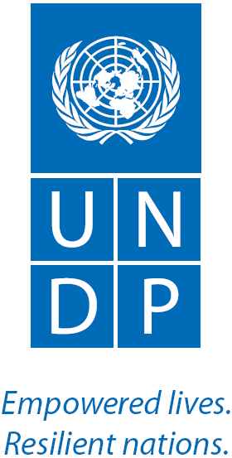

**Capacity Building of the Provedoria for Human Rights and Justice Project**

**3rd Quarterly Progress Report**

**(1 July 2014 – 30 September 2014)**

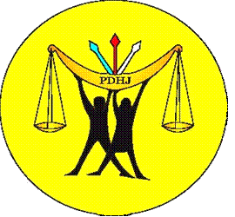 [](http://www.ohchr.org/) 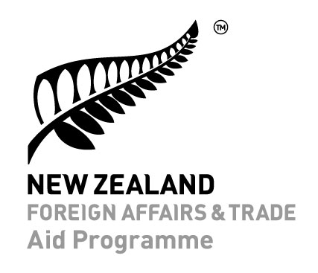

Acronyms and Abbreviations

APF Asia Pacific Forum of National Human Rights Commissions

CAT Convention Against Torture and Other Forms of Cruel, Inhuman and Degrading Treatment

CEDAW Convention on the Elimination of All Forms of Discrimination against Women

CPD-RDTL Popular Resistance Committee of the Republic of Timor-Leste

DAP PDHJ Directorate of Public Assistance

DBG PDHJ Directorate for Good Governance

DDH PDHJ Directorate for Human Rights

DMA PDHJ Monitoring and Advocacy Department

ESCR Economic, social and cultural rights

HRAU Human Rights Adviser’s Unit

HRC United Nations Human Rights Council

KJM Monitoring Management Committee

KRM Revolutionary Council of Maubere

MAP Preliminary monitoring assessment

NGO Non Governmental Organization

NHRI National Human Rights Institution

NZAID New Zealand Aid Programme

OHCHR Office of the High Commissioner for Human Rights

PDHJ Provedoria for Human Rights and Justice

PED PDHJ Promotion and Education Department

PSC Project Steering Committee

SEANF South East Asia NHRI Forum

SAP Standard administrative procedure

SOP Standard operating procedure

UNDP United Nations Development Programme

UPR Universal Periodic Review (of the UN Human Rights Council)

### Contents

Project Data 4

Overview and achievements of the 3rd Quarter 2014 5

Output 1: Applied Human Rights Knowledge and Concepts 7

Output 2: Efficient and effective institutional systems and management structures 15

Output 3: PDHJ has effective information management systems 19

Output 4: Project Management 23

Financial Information 23

Challenges and the Way Forward 25

# Project Data

Project Name Capacity Development of the Provedoria for Human Rights and Justice

Project Number 00073841

Duration of the Project 5 years (2010-2014)

Allocated Budget in 2014 USD 614,315[1]

Sources of Funding for 2014 New Zealand Aid Programme, OHCHR (expected) and UNDP

Executing Agency United Nations Development Programme

Direct Beneficiary Provedoria for Human Rights and Justice

# Overview and achievements of the 3rd Quarter 2014

This report provides a summary of the results and activities of the UNDP “Capacity Development of the Provedoria for Human Rights and Justice” Project (the Project) for the third quarter, 1 July – 30 September 2014.

The Project’s objective is to “improve the institutional capacity of the Provedoria for Human Rights and Justice (PDHJ) to serve the public and promote public institution’s actions in line with human rights principles and standards”. [2]

To achieve this objective, the Project activities are designed to deliver four outputs:

Output 1a: PDHJ staff are knowledgeable about human rights concepts and understand how these concepts are applied in their work;

Output 1b: PDHJ has a workforce skilled enough to implement the institution’s Human Rights mandate including the ability to conduct legal analysis;

Output 2: PDHJ has effective and efficient institutional structures and management systems;

Output 3: PDHJ has effective information and knowledge management systems;

Output 4: Project Management.

During the third quarter (Q3), the Project implemented a draft revised Annual Work Plan (RAWP) as agreed in principle by the Project Steering Committee (PSC) at its meeting in May 2014. The RAWP was approved by the Provedor pending approval by the PSC members. The RAWP re-prioritises and re-aligns the Project’s activities based on the lessons learned from the Project’s mid-term evaluation report and the PDHJ’s own Strategic Plan, Annual Work Plan and key priorities.

Highlights of the 2nd quarter include:

* **Training in human rights treaty reporting and advocacy** for the Convention Against Torture and other Forms of Cruel and Unusual Treatment (CAT) which resulted in PDHJ convening a meeting with civil society to discuss a process for writing a treaty report and a human rights monitor developing an advocacy strategy for addressing cruel treatment in prison detention;
* Testing of the PDHJ’s draft **human rights training manual** for the national police of Timor-Leste (PNTL) by a working group consisting of the Project, the PDHJ, Human Rights Adviser’s Unit and the PNTL;
* The publication of the first **two reports from the monitoring system**;
* The Provedor approved three key components of the new monitoring system; the **standard operating procedures for the monitoring system**, the urgent monitoring system and the role of regional offices in the monitoring system.
* Progression of training on **skills required for the new monitoring system** including new skills in tablet programming, questionnaire development and data analysis. Staff have already used the new technology and skills in their monitoring work to improve the quality of data collection and reporting;
* Sensitisation of **human resources standard administrative procedures (SAPs)** across the PDHJ (Dili and Districts) to improve internal management and coordination;
* Implementation of the new **orientation programme** for PDHJ received positive feedback from new staff and requests for inclusion in the orientation programme by existing staff.

# Output 1: Applied Human Rights Knowledge and Concepts

|  |  |  |  |
| --- | --- | --- | --- |
| **Output 1: Applied Human Rights Knowledge and Concepts** | | | |
| **Reporting Framework** | | | **Results from Q3** |
| **Application of human rights knowledge** | **Indicator** | Demonstrated application of  human rights knowledge (ICESCR  and CAT) in work of PDHJ | Knowledge increase on the Convention Against Torture, treaty report writing and advocacy after training was an average of 57%.  Demonstrated applied knowledge after training included:   * Development of a PDHJ advocacy strategy by human rights monitor for PDHJ to address the issue of cruel treatment and torture in prison detention; * Facilitation of a meeting by the Human Rights Directorate with 5 civil society organisations to present treaty report outline and discuss reporting strategy. |
| **Baseline** | In 2013, the knowledge increase was an average of 60% after 3 trainings; complaint intake, national inquiries and HIV / AIDS & human rights |
| **Target** | Demonstrated applied knowledge post-training by investigators and monitors |
| **Publications** | **Indicator** | Increased number of PDHJ publications effectively integrating human rights issues | This quarter, the PDHJ published two monitoring reports which effectively integrated human rights:   * The report on the joint PNTL and FFDTL operations which contained a human rights analysis; * The report on Timorese children missing during the 1975 – 1999 conflict which addressed the right to privacy and the right to family; * In 2014, 20 investigation reports have been finalised by the Human Rights Directorate which effectively integrate human rights issues. |
| **Baseline** | In 2013, PDHJ incorporated women and childrens’ rights into 2 publicly distributed materials |
| **Target** | Effective integration of human rights issues in at least 3 PDHJ publications in 2014 |

## Human rights training

Findings from the needs assessment into the human rights training requirements for PDHJ Human Rights Directorate staff were implemented in the 3rd quarter with the implementation of the first training workshop and advanced preparation for the second.

The Project conducted a 2.5 day training programme for treaty report writing under the Convention Against Torture (CAT) and advocacy for CAT issues. Participants were drawn from the Human Rights Directorate, Department of Public Assistance, Chief Department Public Relations and each of the 4 Regional offices. Of the 17 participants, 9 were men and 8 were women. The training was delivered by the UN Human Rights Adviser, an OHCHR staff member, PDHJ staff and the Project Manager. The training drew on previous trainings conducted by the Project on CAT and provided an understanding of CAT for new staff and staff from other Directorates who had not attend the Project’s earlier CAT training. The training was very practical and focused on CAT treaty reporting requirements and advocacy work that the PDHJ could do in relation to CAT issues. Results from pre and post tests revealed a significant increase in knowledge (57%) as a result of the training. The average pre-test result of 35% increased to 81% after the training. Staff were able to access a Tetun-language version of CAT and relevant general comments in Tetun in the Compilation of Human Rights Instruments which was produced by the Project and revised editions were distributed to each participant at the training. The Tetun language course materials will also provide a useful reference point for PDHJ staff researching torture and ill-treatment issues in the future.

The training was quickly implemented by PDHJ. The PDHJ has the statutory power to contribute (in an advisory capacity) to the development of the Government’s report to the CAT Committee and to prepare its own parallel report to the Committee. Upon their return from the training, the PDHJ organised and hosted a meeting with five relevant civil society organisations to plan the writing of the treaty report and prioritizing issues of concern to PDHJ and to civil society. PDHJ also distributed 7 copies of the Compilation of Human Rights Instruments (Tetun) to these organisations to support them by providing the relevant treaty and key general comments in Tetun language for their ease of reference during the report writing process.

After the training, the Project Manager also supported a human rights monitor in his application to participate in the Asia Pacific Forum Torture Ambassador programme. With Project support, the monitor developed a holistic advocacy strategy to reduce torture and cruel treatment in prison detention and was accepted into the programme.

A 3 day training workshop as a basic introduction to economic, social and cultural rights has been planned for the 4th quarter.

## Support for implementation of the monitoring system

Following the Project’s capacity development strategy, trainings on the use of the PDHJ monitoring system framework have been completed and the monitoring system is now being implemented by human rights and good governance staff for the following areas: border security, access to maternal and reproductive health, the use of state assets and access to public services (business licensing procedure). Mentoring of monitoring field work was scaled back by the end of this quarter after intensive mentoring support for the monitoring staff for the first half of this year.

### Mentoring field monitoring

The Project provided mentoring support for two human rights monitoring activities in July, in particular for questionnaire development on the access to justice and access to health monitoring topics. As a result of the mentoring support, the monitoring questionnaires align more closely with the relevant indicators in the monitoring plan and are consistent with international best practice.

The mentors also supported the development of an interview schedule by the principal monitors for each monitoring team. This tool was used by PDHJ to improve the accountability of monitors for the number of interviews conducted each day during a field trip.

The national technical mentor provided mentoring on a monitoring field trip to Same for the Good Governance Directorate in August. The focus of the mentoring was sample drawing and interview techniques and extra support was provided to a new monitoring staff member.

The mentors also had a positive impact on PDHJ public relations and awareness of PDHJ by encouraging monitoring staff to fully explain the mandate of the PDHJ with each respondent and their family prior to the interviews taking place. In an effort to better coordinate the different functions of PDHJ and to use resources effectively, the monitoring staff also distributed information about PDHJ’s role and mandate to respondents during the monitoring exercises.

The progress of Human Rights Directorate monitoring staff continued to be assessed by the mentors through the field monitoring assessment developed by the Project and PDHJ in the 2nd quarter. All good governance monitors achieved a grade of ‘good’ in their assessment and therefore do not require further mentoring support to conduct an interview. However, the assessment revealed that the Good Governance Directorate requires continued support to develop a questionnaire.

Human Rights Directorate staff have now been assessed at a ‘good’ standard (therefore not requiring further monitoring support), except for the pre-testing of questionnaires and interviewing techniques.

Further mentoring on the skills which require further development will be performed by the national technical mentor in the 4th quarter.

### Monitoring publications

### One of the highlights of the 3rd quarter was PDHJ’s publication of two monitoring reports and subsequent public dissemination.

### In the first quarter of 2014, the PDHJ monitoring team implemented the new urgent monitoring system for the first time to monitor PNTL and security forces’ actions against two proscribed organisations with technical assistance from the UNDP Project. In this quarter, the first report of the Department of Monitoring and Advocacy (Human Rights) was published (“Joint Operations Report”). The report related to State actions in 10 Districts based on Parliamentary Resolution No. 4/2014 (4th March 2014), Government Resolution No. 8/ 2014 (31st March 2014) and Government Resolution No. 13/2014 (7th May 2014). These resolutions declared certain groups (who were seen as threats to the State) as being illegal. Subsequently, the National Police of Timor-Leste (PNTL) and Defence Force of Timor-Leste (F-FDTL) engaged in a joint operation to pursue these illegal groups.

### The Joint Operations Report was drafted by PDHJ with support from the Project’s monitoring mentor. The report included an analysis of the actions of the State, the legal basis for the actions and The Joint Operations Report included an analysis of the State’s actions based on international and national human rights obligations including the right to freedom from intimidation, freedom of opinion and expression, freedom of movement and detainee rights. The report also included a legal analysis of the resolutions and findings from monitoring activities in Baucau, Aileu, Ainaro, Bobonaro, Covalima, Ermera, Manatuto, Manufahi and Oe-cusse. Finally, PDHJ made recommendations to the President, National Parliament, the Government, the PNTL and F-FDTL and the Public Ministry.

In the 3rd quarter, the PDHJ also released a report about its cooperation with the Indonesian national human rights institution (Komnas-HAM) on the issue of Timorese children separated from their parents during the 1975 – 1999 conflicts (“Ema Lakon” Report). The exercise involved cross-matching data from Indonesia with records in Timor-Leste with a view to enabling family reunion. The report engaged with several human rights issues including the right to privacy and confidentiality of information and the right to family.

### These reports were developed with the support of the Project’s monitoring mentor, under the new monitoring system which was developed and tested with Project support. The Project also supported the urgent translation of the Joint Operations Report and printing of the report to assist the broader dissemination of the report to international organisations by PDHJ senior management in India at the Asia Pacific Forum of NHRIs (APF) Annual General Meeting. The second report was based on an urgent monitoring report template developed by the Project’s monitoring mentor.

### PDHJ submitted the Reports to Parliament, the President and the relevant state entities about which recommendations were made (for example, PNTL and F-FDTL). PDHJ met with civil society groups on 9 September 2014 to announce the release of the reports. The Joint Operations Report has been disseminated to civil society organisations through formal (e.g from Parliament) and informal channels. It is hoped that in the future PDHJ will authorise publication of the reports on PDHJ’s website.

### Training for monitoring system

In July, the national technical mentor conducted a 3 day training programme on the Statistical Package for the Social Sciences (SPSS) which is a tool for data tabulation and data analysis. Training in SPSS helps PDHJ staff to analyse data and produce faster and more accurate results (whether for monitoring or other activities such as the perception survey). The mentor trained 16 PDHJ staff members from Dili office from across PDHJ (7 female participants and 9 male participants). The training included developing databases for questionnaires; inputting data into a database; cleaning, importing, exporting and merging data; transforming variables; data analysis and developing charts to graphically represent results using excel. At the conclusion of the SPSS training, all staff were able to develop a database from a questionnaire.

Since the SPSS training, the monitors in the Human Rights and Good Governance Directorates have developed 3 databases in SPSS based on data they collected during their field monitoring for three monitoring topics, with only minor mentoring from the national technical mentor. Topics included access to justice at the border areas, access to health (the SISCA Program) and business licensing (good governance). The technical mentor has assessed the quality of random route selection technique (for selecting households for interview) as ‘good’ which means that no further support required to monitors).

The Project will conduct asecond SPSS training in the 4th quarter for PDHJ staff who require SPSS for their reporting functions, to strengthen PDHJ’s capacity to produce quality, results-based reports.

### Perception survey

USAID funded PDHJ to conduct an outreach program from its 4 regional offices and required an evaluation of the program in 2014 by means of a perception survey. PDHJ requested technical support from the Project this quarter to complete its reporting obligations to USAID and the Project’s work plan was modified to include this activity because the survey was closely aligned with the Project’s technical support for the monitoring system and because of the strategic importance of good quality data about awareness of human rights in Timor-Leste and public awareness of PDHJ and its mandate.

In this quarter, the Project’s national technical mentor therefore supported the design of the USAID / PDHJ perception survey and developed the perception survey proposal which included recommendations about the required equipment, the staffing requirements and the timetabling for the survey. This plan was approved by senior management. The Project’s national technical mentor also provided technical and mentoring support for the PDHJ staff involved in the perception survey.

In August, the national technical mentor conducted a 4 day perception survey training programme for PDHJ staff. Of the 33 PDHJ staff who participated, 42% were female 58% were male; 42% were from the regional offices and 58% were from head office. The training covered all aspects of conducting a perception survey including developing indicators, sampling, developing a questionnaire, tablet programming, interviewing techniques, designing a random route and pre-testing the questionnaire. The mentor assessed that skills in questionnaire development and sampling design require further support in the 4th quarter. Staff will apply the knowledge gained from the training when they conduct the perception survey in the 4th quarter.

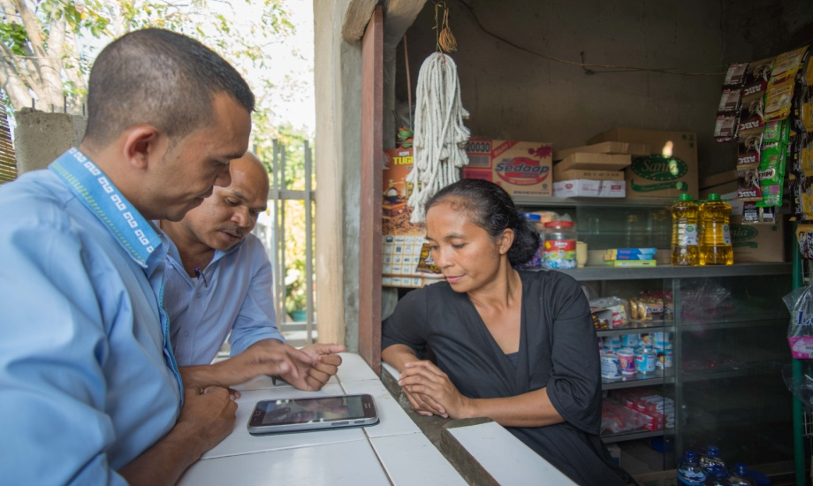

*PDHJ staff pre-testing questionnaires with PDHJ’s new Samsung Galaxy tablets*

*(Caicoli, Dili August, 2014)*

At the perception survey training, staff were also trained to use the new Samsung Galaxy 3 tablets for field monitoring data collection (including the perception survey). One advantage of electronic data collection over paper-based methods is the ability to monitor the data collection in real-time online through GPS and to verify data. This will contribute to data integrity, increase the credibility of PDHJ monitoring reports (and the perception survey). One limitation PDHJ experienced with using electronic tablets is that programme downloads were seriously affected by power outages at PDHJ which cut access to the internet and the slow internet speed. Access to reliable power supply and high speed internet are issues the Project has flagged should be addressed by PDHJ as soon as funding permits.

After the training, the Human Rights Directorate staff used their tablets for data collection during field monitoring exercise in Oe-cusse. The staff programmed the tablets themselves with the relevant questionnaire, based on the knowledge they gained during the perception survey training, with only minor support from the mentor.

The Project’s recommendation to include a broader range of questions in the survey to allow better baseline data for PDHJ (for example, awareness of the nascent national human rights action plan), was also accepted. The survey now canvasses views on a range of topics including awareness of PDHJ, preferences for receiving information and opinions on a range of human rights and good governance issues.

The Project Manager has also advocated that the scope of the perception survey be expanded to include not only the Districts (as required by USAID) but also Dili, to provide more comprehensive data for PDHJ to use in future planning and advocacy work.

As a result of the Project’s technical support for the design of the perception survey and questionnaire, the perception survey results will provide a solid basis for PDHJ programming, a baseline against which to measure the impact of future activities by PDHJ and a useful advocacy tool. The data will be a valuable resource for government and non-government organisations that are working on human rights or good governance issues in Timor-Leste.

## Human Rights Standards and Violations Manual

The *Human Rights Standards and Violations* *Manual* was translated into Tetun, used in human rights training and tested by PDHJ staff in the 3rd quarter. Feedback received from the Human Rights Adviser’s Unit (UN) and from PDHJ staff has been incorporated into the Manual.

The Manual contains a simple explanation of human rights standards, based on national and international law, the identification of the obligations of the State regarding each of the standards and examples of violations of such obligations. The Manual was used by PDHJ monitoring staff to develop their monitoring plans and to form the basis for the legal analysis of human rights implications in the PDHJ’s monitoring reports.

## Human rights Training Manual for the PNTL

The PDHJ’s human rights training manual for the PNTL has been drafted with support from the Project (principal author and editor) and the Human Rights Adviser’s Unit (contributing author to chapter 4 and contributing towards the printing costs).

The manual is written in Tetun and consists of 4 modules; police duties and human rights; policing and the use of force; arrest and detention and policing and vulnerable peoples. The manual includes an up to date legal analysis of relevant laws that apply to human rights and policing in Timor-Leste and sets out this information in a simple way that relies heavily on practical exercises. It includes lesson plans, suggested topics for discussion, revision points and assessment templates.

The manual will be accompanied by a CD containing training materials; an electronic version of the Manual, relevant law, power-points and handouts and training videos.

The PDHJ is already using the draft manual in its training of PNTL cadets. It will use the manual in the future to conduct train the trainer workshops, subject to funding.

The Project developed the Manual in close collaboration with PDHJ, the HRAU and the PNTL Training Centre. The Manual will be tested with PNTL trainers in the 4th quarter prior to finalisation and launch on International Human Rights Day, 10 December 2014.

## National Human Rights Action Plan

### The Government of Timor-Leste has announced its intention to develop a national human rights action plan. This activity does not form part of the Project’s Annual Work Plan however the Project provided technical support to the PDHJ staff member who has been appointed to the National Human Rights Action Plan drafting committee.

### The PDHJ also distributed 60 Tetun-language compilations of international human rights instruments (which were published with support from the Project) to members of the drafting committee. This compilation is the only Tetun-language compilation of international human rights instruments available in Timor-Leste and access to international human rights law is essential to the national human rights action plan drafting process. The compilation is also available in searchable electronic format on the PDHJ’s new website which was developed with Project support (see below).

Finally, baseline information about the current state of human rights observance is an important first step for the development of a national human rights action plan. The Project Manager advocated for the inclusion of relevant questions in the PDHJ’s perception survey to begin the process of collecting the required baseline data.

Output 2: Efficient and effective institutional systems and management structures

|  |  |  |  |
| --- | --- | --- | --- |
| **Output 2: The PDHJ has effective and efficient institutional structures and management** | | | |
| **Reporting Framework** | | | **Results from Q3** |
| **Increased public awareness of PDHJ mandate activities & results** | **Indicator** | Increase in awareness of PDHJ through the PDHJ website and other publications | * The website was tested and finalised in July. * During Q3 there were 337 users of the website, 42.5% of which were new visitors (143). * The baseline assessment of 1 staff member to update and maintain the website was completed and results from this evaluation and the evaluation of a second staff member will be reported in Q4. |
| **Baseline** | At the start of 2014, PDHJ had no public website |
| **Target** | By the end of 2014, PDHJ will have a public website and will be able to update it and maintain it and the website will have 400 hits (new users). |
| **Compliance with internal procedures - monitoring** | **Indicator** | Number of monitoring activities in compliance with internal procedures | * The number of monitoring activities conducted in compliance with internal procedures will be reported from the 4th quarter because the 3 key monitoring SOPs were only approved by the Provedor this quarter. * Compliance with the monitoring system is well underway. The system has been tested and applied during field work throughout 2014. |
| **Baseline** | Internal procedures to be developed by end Q2 |
| **Target** | 80% of monitoring activities completed after finalisation of internal procedures will be conducted in accordance with the procedures. |
| **Compliance with internal procedures – human resources** | **Indicator** | At least 4 new human resources internal procedures to be developed by PDHJ in 2014 | * The Project has supported the development of 7 human resources internal procedures in 2014. * 5 of those SAPs have been approved (overseas training, access to the leave system, library, correspondence system, Directive Council Regulation) * 2 of the SAPs are well advanced but are awaiting final approval by the Provedor (orientation, performance evaluation). * PDHJ has applied its SAP for overseas training for 100% of overseas training opportunities since May 2014. * Although the orientation programme has not been formally approved by the Provedor, it has been successfully implemented for 100% of new recruits from 2013 and 2014 including permanent public service staff and international advisers. |
| **Baseline** | PDHJ does not have internal procedures for attendance at external training and orientation of new staff |
| **Target** | By the end of 2014, PDHJ will have:   * applied its internal procedure for attendance at overseas training for at least 80% of overseas training opportunities; and * after the approval of the PDHJ orientation programme SOP, all new PDHJ staff will complete the orientation programme. |

## Standard operating procedures (monitoring)

On 12 September 2014 the Provedor signed and approved three standard operating procedures (SOPs) for the monitoring system, which were all developed with the support of the Project’s monitoring mentor. These procedures are the role of the regional offices in monitoring, the urgent monitoring system and the monitoring system. The Project also supported the development of the monitoring management committee SOP which is final, pending approval from the committee itself.

These standard operating procedures are already being fully implemented. Part of the reason for the speedy implementation of the procedures was the highly participatory method used by the monitoring mentor to develop the procedures. The method, although effective, was very time consuming. Each procedure involved numerous lengthy meetings and discussions and testing prior to formal approval by the Provedor. This methodology has been well-received by PDHJ senior management and staff. A lesson learned from this Project is that sufficient time should be allowed for a highly participatory approach to be taken to the development of internal procedures.

The drawback to this participatory methodology is the extensive time it takes to develop each SOP. As a consequence, the monitoring mentor was unable to develop the two final components of the monitoring system, before his contract expired in September 2014. The outstanding components are PDHJ’s monitoring advocacy strategy and guidance on report writing and a reporting template for monitoring staff. The PDHJ has now employed the Project’s monitoring mentor directly to enable his support to continue to PDHJ on the monitoring system after the closure of the Project.

When the advocacy and reporting components of the monitoring system are developed by PDHJ, the monitoring system will be complete. It is hoped that if these components are finalised by PDHJ prior to the Project’s closure, the Project will be able to support the development and publication of a monitoring manual which incorporates all the components of the monitoring system.

***Human resources recruitment support***

In this quarter, the human resources mentor provided technical support to the PDHJ to conduct a major recruitment drive to increase the total number of public sector staff by 14 to 98 (which excludes temporary staff and international advisers).

This mentoring support was essential because the PDHJ will undergo another recruitment drive in 2015 to increase total public sector staffing levels to 135.

The mentor is also supporting a review of the PDHJ staffing profile which is included in PDHJ’s organic law. The current organic law restricts the ability to promote staff due to a limited number of positions at each grade.

In the 2nd quarter, a new staff orientation program was developed by the PDHJ with the support of the national human resources mentor, to orient new staff in relation to the PDHJ, its mandate, functions and powers and internal procedures. The orientation program was implemented by PDHJ, with the support of the Project’s national human resources mentor, for the first time this quarter. The program was completed by all 14 new public sector employees, 3 staff members who were recruited in 2013 and 5 international advisers. PDHJ staff commented that the program was very useful. PDHJ staff who are not recent recruits also expressed an interest in participating in the orientation program to allow them to gain a better understanding of PDHJ as an institution.

***Human resources procedures***

The standard administrative procedures *Nomination of Staff to Participate in Courses or Trainings* and *Employee Leave*were developed with Project support in the 1st quarter. These procedures are now being fully implemented by PDHJ with the support of the Project’s national human resources mentor. The PDHJ has applied the nomination and selection procedure for 100% of staff attending overseas training since May 2014. In this quarter, 9 candidates for overseas training were interviewed and 8 were successful. Staff are now reporting on the outcome of trainings, in accordance with the procedure. In this quarter, 9 staff who attended overseas training presented their reports to PDHJ staff as a way of sharing the knowledge gained during training. Topics included undertaking effective investigations; gender mainstreaming and monitoring; trafficking of women and children in southern Asia and mediation skills. These presentations and training materials will be included in PDHJ’s training, promotion and education database (see below for details).

The human resources mentor supported the sensitisation of all staff at PDHJ to human resources standard administrative procedures in this quarter. All staff from national office, the Good Governance and Human Rights Directorates, Administration and Finance and the Public Assistance Directorate have now participated in information sessions about all human resources standard administrative procedures. These include, job descriptions, in-country and overseas training, leave and the orientation program. The purpose of these sensitisation exercises is to ensure that all PDHJ staff are familiar PDHJ’s human resources procedures and can implement them and to provide mentoring for job descriptions. The mentor modelled information sessions for human resources staff who are now able to organise and execute information sessions which are well-planned and involve active participation by PDHJ staff.

Other standard administrative procedures which are in progress (internal performance evaluation) were unable to be finalised this quarter due to the transition in leadership at PDHJ. The orientation standard SAP has been finalised and implemented pending approval due to the delay in the appointment of the new Provedor.

***External training opportunities and international human rights engagements***

The Project provided technical support for several PDHJ staff members to pursue international training opportunities this quarter, including a course at Raoul Wallenberg Institute (RWI) in Sweden (training on design of a police training manual), a fellowship in the U.S.A on leadership, law and good governance and the Asia Pacific Forum Torture Ambassador Programme.

The Project Manager and monitoring mentor also supported two staff on a weekly basis throughout the 2nd and 3rd quarters, to participate in the RWI training on gender and the human rights of women. Subsequent to the training, the participant shared her knowledge at a peer to peer training for PDHJ staff. This report-back is required under the PDHJ’s overseas training standard operating procedure which was developed with the Project’s support (see above).

The Project is regularly called upon to support PDHJ’s participation in external trainings provided by other development partners. Support includes logistics, translations and technical support before and during the training as required.

The Project provided extensive support to PDHJ senior management this quarter to support their attendance at international human rights meetings. Support included speech writing, translations, logistics and strategic communications support. Meetings included the Senior Executive Officer’s meeting (July), the Asia Pacific Forum’s Annual Meeting (September), interviews with the Centre for Economic Rights regarding the new monitoring system (September) and the SEANF technical working group meeting on Human Trafficking.

***Internal coordination and reporting***

This quarter, the human resources mentor produced a reporting template for use in regional offices and mentored each staff member in 3 regional offices on how to write effective monthly and final reports using the template.

In response to the mid-term evaluation of the Project (2013) which recommended that all staff at PDHJ should have knowledge of human rights, the national human rights mentor also initiated a peer-to-peer training programme on human rights concepts to enhance the knowledge of human rights to 28 PDHJ staff in the Administration and Finance Directorate. The initial training session was conducted by the Chief Department Promotion and Education (Human Rights). Staff feedback was very positive. The Project will continue to advocate for a broader, systematic peer-to-peer training programme at PDHJ after the election of the next Provedor.

Internal reporting and coordination systems remain weak at PDHJ. The Project advocated strongly this quarter for strengthened reporting and coordination mechanisms, including resumption of the Directive Council meetings, an annual retreat, conclusion of the drafting of the administrative structure of PDHJ (the ‘organics’), results based reporting and performance management. The Project’s national human resources mentor also drafted reporting templates for each Directorate. It is hoped that these initiatives can be implemented soon after the election of the next Provedor.

## Support to strengthen knowledge management and skills - Annual and strategic planning processes

With the support of the Project,the PDHJ developed their *Annual Action Plan 2015* and 3 year *Strategic Development Plan (2015 – 2017).* The Project supported the PDHJ to apply a human rights based approach and results based methodology for the first time in PDHJ’s strategic planning processes. Following this process, the Deputy Provedor (Human Rights) requested that PDHJ Senior Management participate in results based management training.

# Output 3: PDHJ has effective information management systems

|  |  |  |  |
| --- | --- | --- | --- |
| **Output 3: PDHJ has effective information and knowledge management systems** | | | |
| **Reporting Framework** | | | **Results from Q3** |
| **Support to case file and management system** | **Indicator** | PDHJ has capacity to manage the eCMS system including outsourcing maintenance tasks as required | * No results in Q3. * Consultant recruited. * Audit of eCMS will be conducted in October and consultant will implement based on findings and recommendation of the audit team. |
| **Baseline** | At the end of 2013 PDHJ had no eCMS manuals or capacity to make minor revisions or updates to eCMS |
| **Target** | PDHJ can make minor revisions or updates to eCMS and engage the system developer on larger maintenance issues |
| **Storage and categorisation of knowledge management materials** | **Indicator** | # of knowledge management materials stored and categorised with the PDHJ library and Human Rights Directorate | * All Library resource materials have been categorised and stored by the end of the 3rd quarter. * The collection of materials from the Human Rights Directorate commenced in the 3rd quarter. * All Legal Department knowledge management materials have been categorised and stored. |
| **Baseline** | Internal systems being established in the last quarter of 2013 |
| **Target** | The PDHJ Library and Human Rights Directorate have stored and categorised at least 60% of their knowledge management materials by the end of 2014 |
| **Use of knowledge management materials** | **Indicator** | # of knowledge management materials developed in the Project in 2014 used by the PDHJ Human Rights Directorate staff | * The Compilation of International Human Right instruments is being used by Human Rights Directorate staff to contribute to the national human rights action plan, implement training for the PNTL, develop an advocacy strategy for PDHJ on CAT issues and to develop a human rights training manual for the PNTL. * The PNTL Human Rights Manual and the Human Rights Manual are both in draft but are already being used by PDHJ Human Rights Directorate staff to conduct training, write investigation reports and to develop human rights monitoring plans. |
| **Baseline** | At the end of 2013, the Human Rights Manual, Revised Compilation of Human Rights Instruments and the PNTL Human Rights Manual had not been developed. |
| **Target** | By the end of 2014, at least 80% of Human Rights Directorate staff are making regular use of the Human Rights Manual, Compilation of Human Rights Instruments and PNTL Human Rights Manual. |

## Electronic Case Management System

The Project supported the introduction and implementation of an electronic case management system for PDHJ for several years. However, the Project Manager received feedback from the PDHJ that the system was not being used. Upon inspection, it was revealed that the PDHJ had reverted to a paper-based case register.

The Project will address the underlying issue of technical problems with e-CMS by liaising with the maintenance contractor to arrange an audit of the system and resolution of all remaining technical problems. The first stage of the audit will take place in October prior to the commencement of the e-CMS mentor. The second stage of the audit will be completed in December 2014 prior to the conclusion of the e-CMS maintenance contract and the end of the Project on 31 December 2014.

The Project Manager recruited an e-CMS mentor in the 3rd quarter to develop a training plan for each user of the system and to mentor staff according to that plan on an individual basis until competency is achieved.

One ongoing issue for the PDHJ will be the cost of maintaining the e-CMS system. The company currently contracted to provide maintenance charges $25,000 for maintenance of the system. The Project Manger has raised the need to maintain the e-CMS system with PDHJ and advocated for inclusion of this budget line in PDHJ’s budget proposals for 2015 and beyond. The Project will also explore other options for maintenance and issue recommendations to PDHJ prior to Project closure.

## Website

The Project has been supporting the development of a PDHJ website (<http://www.pdhj.tl>).The objective of the website is to disseminate information on PDHJ’s work and its activities, to share human right laws and treaties and to raise awareness on human rights issues in Timor-Leste. At the request of PDHJ, the website has been drafted in three languages - Tetum, English and Portuguese. The Project has engaged in discussions with PDHJ about the sustainability of a tri-lingual website given the lack of Portuguese and English competency among relevant PDHJ staff. The Project has recommended that PDHJ consider employing a full-time translator and interpreter when funds permit, to support PDHJ, present speeches and papers at international fora as well as providing day to day language support for knowledge products and strategic communications. In the interim, PDHJ has hired an international adviser to fill this gap, but PDHJ has limited Portuguese language capacity since the departure of the two Portuguese legal advisers.

The website includes a tool to allow analysis of users, page views and user demographics, which will enable PDHJ to understand its internet audience and target information accordingly.

**Statistics for** [**www.pdhj.tl**](http://www.pdhj.tl) **(1 July 2014 – 30 September 2014)**

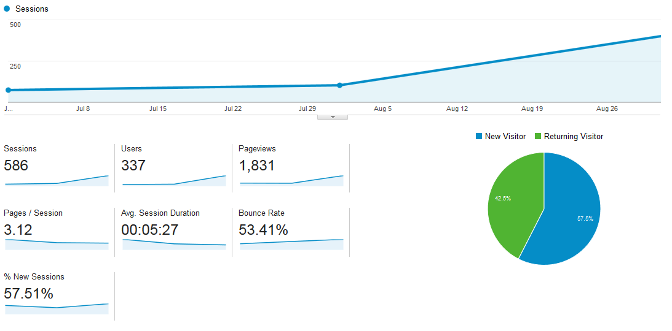

Source: <http://analytics.google.com>

The Project’s national technical mentor has mentored the Chief Department Public Relations to update the website with news and documents. The PDHJ website is now updated by PDHJ regularly without assistance from the Project. The training in generating reports about website usage will be conducted in the next quarter.

The launch of the website is planned to take place in December after the appointment of the new Provdedor. The website already includes a number of reports and publications by PDHJ and the Project will continue to provide translation support for PDHJ’s key strategic documents and reports so that they can be widely accessed by the broader international community.

## Library Plan and Knowledge Management system

The Project, in coordination with Raoul Wallenberg Institute (RWI) and the PDHJ, has taken several steps to ensure a more effective library, archive and knowledge management system.

In the 3rd quarter, the Project supported the revision and finalisation of the library Regulation which has now been approved by the Provedor.

Several factors outside the control of the Project have affected the ability of staff to access resources at the library. Until the library system is linked by intranet to PDHJ staff desktops, staff will be reliant on the librarian and the librarian’s database to research the database and borrow and return books to the library. Regional staff will not have access to library resources until PDHJ regional offices have internet and intranet access. The Director Administration and Finance has re-deployed the skilled librarian who was trained by RWI, to other duties at PDHJ. PDHJ has also reallocated the librarian’s computer and desk (which contains the library database) to a new international staff member. Physical access to the library is also severely restricted because the PDHJ is constructing an extension to the rear of the PDHJ site in Dili and the library is usually in use as a meeting room.

Nevertheless, in the 3rd quarter, staff were encouraged to familiarise themselves with the resources in the library and to use these resources in their work. For example, as part of the human rights training on CAT reporting and advocacy, PDHJ staff were encouraged to use a range of resources from the library as part of the research for the practical exercises in their training program (see photograph below).

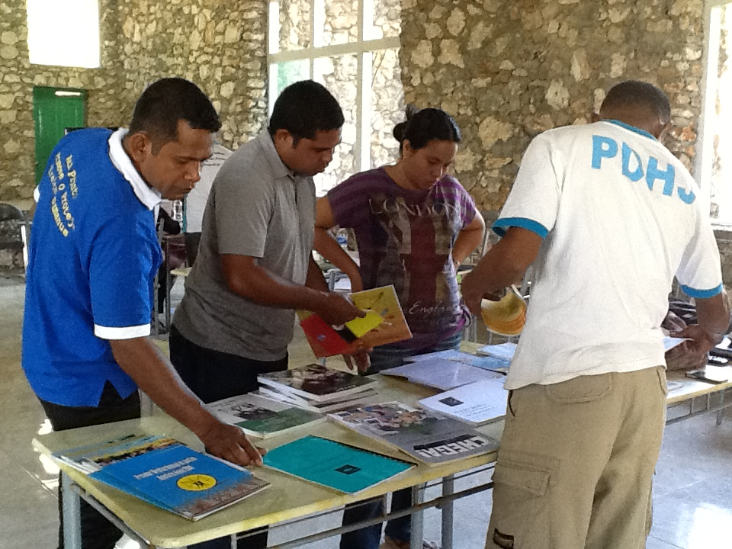

*Staff at the training on CAT treaty reporting and advocacy using PDHJ library resources to develop an advocacy strategy*

*(Com, Timor-Leste, September 2014).*

The Project also facilitated a field visit between PDHJ’s former librarian and interim librarian to the Xanana Gusmao Reading Room, which maintains its library using the KOHA database used by PDHJ. The field visit gave PDHJ staff insight into new cataloguing systems for PDHJ and discussions about improvements that could be made to the library when PDHJ renovations are completed in 2015.

# Output 4: Project Management

## Revised Annual Work Plan

After receiving endorsement from the PSC to revise the Annual Work Plan at the May PSC meeting, the Project Manager consulted PDHJ and OHCHR and revised the Annual Work Plan to focus on activities consistent with both the PDHJ’s 10 strategic priorities and the recommendations from the Project’s mid-term evaluation report (2013). This plan was signed by the Provedor and implemented from the 3rd quarter pending final approval by the remaining Project Steering Committee members.

***Human resources***

Several staff were recruited in this quarter to commence in the 4th quarter. New staff include the electronic case management specialist, the information technology specialist (website and training, promotion and education database) and a mediation and conciliation mentor. The human resources mentor and the national language officer’s contracts were extended until 31 December 2014 and the monitoring mentor’s contract ended.

# Financial Information

# 

At the end of the 3rd quarter, the Project had spent approximately US $355,444.63 out of the USD 618,240.00 budget allocated for 2014. The amount represents about **57** % of the allocated budget.

**Project Budget and Funding**

|  |  |  |
| --- | --- | --- |
| **Project Funding Source (Donor)** | **2014 Annual Work Plan Budget** | **Expenditures as of 30th September 2014** |
| NZAID | US $ 518,514.00 | US$331,443.49 |
| OHCHR | US $ 49,726.00 | US $ 3,210.64 |
| UNDP TRAC | US $ 50,00.00 | US $20,790.50 |
| TOTAL | **US $ 618,240.00** | **US $355,444.63** |

*\** *OHCHR funds were approved in June 2014 but have not been disbursed to Project by 30 September 2014. Funds disbursed to the Project are NZAID ($518,514) and TRAC funds ($50,000) only. For this reason, activities funded by the agreement with OHCHR have been charged to New Zealand funds and will be reversed to the OHCHR account when OHCHR funds are received.*

### Project Expenditure Details per Project Output

|  |  |  |
| --- | --- | --- |
| **Project Output** | **Project Budget 2014 per Project Output** | **Expenditures per Project Output as of 30th September 2014** |
| **Output 1** Human Rights Knowledge | US $183,018.00 | US 120,220.02 |
| **Output 2** Institutional Structure and management | US $117,850.00 | US $ 33,454.21 |
| **Output 3** Information and knowledge management | US $36,220.00 | US $ 15,589.90 |
| **Output 4** Project Management | US $232,227.00 | US $186,180.50 |
| **TOTAL** | **US $569,315.00** | **US $355,444.63** |

## Challenges and the Way Forward

The main challenge facing the Project in this quarter has been the delayed election of a new Provedor by Parliament. The Provedor’s appointment expired in March 2014. The Project continues to plan activities on the basis of approval by the Provedor knowing that re-approval may also be required when the new appointments are made. While many activities can continue at staff level during this period (for example monitoring mentoring and human resources mentoring and training activities), several activities designed to strengthen the coordination of management and reporting processes have been delayed or deferred to early in the 4th quarter when it is anticipated that a new Provedor will commence in the role. These activities include finalisation of the administrative structure of PDHJ (‘the organics’), and results based management training.

The Project also identified during this quarter the risk of duplication and overlap when two development partners (in this case USAID and the Project) are invited to undertake the same activity without the necessary coordination and information sharing. To address this issue, the Project Manager initiated direct contact with USAID to identify their areas of support to PDHJ and to avoid duplication of funds for a single purpose. The Project’s staff conducted the training to PDHJ staff on survey tools and methodologies and preparation for the perception survey, both of which were USAID funded activities. The Project also provided support to PDHJ to develop a reporting strategy and reporting templates for PDHJ to use for its USAID reporting requirements.

The Project Manager also recommended to PDHJ that development support should be better co-ordinated in the future. At the end of the quarter, PDHJ appointed an international adviser as a donor liaison officer. It is hoped that in the future a national staff member will fill this position and that the role will serve to improve co-ordination and transparency in future multi-partner support to PDHJ.

The key activities scheduled by the Project for the 4th quarter include:

* Training in the fundamentals of economic, social and cultural rights;
* Results based management training;
* Testing, publication and launch of the Human Rights Training manual for the PNTL;
* Technical support for PDHJ’s perception survey to be conducted in 4 Districts; (questionnaire design, enumerator’s training and supervision of data collection and data analysis);
* Launch of PDHJ’s website and mentoring throughout the 4th quarter on updating and maintaining the website; and
* Consolidating and entrenching the electronic case management system into PDHJ policy and practice through training, mentoring and knowledge products.

1. *Includes funds from Office of the High Commissioner for Human Rights which were approved in June 2014 but have not been disbursed to the Project.*
2. *UNDP Timor-Leste, Country Programme Action Plan 2009-2014 (extended to 2014), (Output 1.4)*